

**Bachelor of Information Technology (Hons)**

**Assignment Cover Sheet**

Course Code: EC3119 Course Title:Database system

AssignmentTitle: Database Report Due Date:2023-09-12

Date Submitted: 2023-09-12 Lecturer Name: Mr.Sameer kayastha

**To be completed if this is an individual assignment**

I declare that this assignment is my individual work. I have not worked collaboratively nor have I copied from any other student’s work or from any other source except where due acknowledgement is made explicitly in the text, nor has any part been written for me by another person.

StudentName: Student ID:________________ Signature: ________________

**To be completed if this is a group assignment**

We declare that this is a group assignment and that no part of this submission has been copied from any other student's work or from any other source except where due acknowledgement is made explicitly in the text, nor has any part been written for us by another person.

Student ID Student Name Signature

_________ __ RAJIV YADAV________________________ __________

_________ __RAJU CHAUDHARY __________________ __________

_________ __ _TEJ KUMAR YADAV_______________ ____ ______

_________ __ _BIJAY RAI AMAT___________________ __________

_________ __ _RASIK SHAKYA __________________ __________

Lecturer's comments: _______________________________________________________

_________________________________________________________________________

Total Marks: ______________ Lecturer's Signature:_________________

**Feedback to Student:**

I/We acknowledged receiving feedback from the lecturer on this assignment.

Student’s Signature: ____________ _____________ _____________ ___________

**Extension certification:**

This assignment has been given an extension and is now due on _______________.

Lecturer’s Signature: _____________

**CONTENTS**

1. **INTRODUCTION**

**i.Background**

**ii.Problem with the Existing System**

**iii.Significance of the proposed system**

1. **OBJECTIVES**

**i.Objective of the proposed system**

1. **PROBLEM STATEMENT**

**i.What’s new with the proposed system**

1. **SCOPE**

**i.Scope of the proposed system**

1. **HARDWARE AND SOFTWARE SPECIFICATION**

**i.Hardware requirements**

**ii.Software requirements**

1. **ENTITY RELATIONSHIP DIAGRAM**

**i.ER-Diagram with Attributes**

1. **RELATIONAL SCHEMA**

**i.Data schema documentation**

1. **NORMALIZATION**

**i.Normalization**

1. **PROPOSED DATABSE TABLES**

**i.Student Table**

**ii.Courses Table**

**iii.Class Table**

**iv.Grade Table**

**v.Teacher Table**

**vi.Attendence Table**

1. **CONCLUSION**

**i.Summary of the Project**

**ii.Advantage of the Developed System**

**iii.Future work and Suggestion**

**Background of The School Management System Database**

1. **Introduction to Current System:**

The education sector has an important role in shaping the future of individuals and society. In today's digital age, effective management of educational institutions is essential to ensure the smooth running of schools and improve the learning experience for students. Traditionally, schools have relied on manual processes and fragmented systems for administrative tasks, resulting in inefficiencies and difficulties in maintaining accurate records.

1. **Problems with the Existing System:**

Existing school management systems, if they exist at all, often suffer from several problems that hinder their effectiveness. These problems include:

1. **Data Redundancy:** Manual data entry and storage leads to data redundancy, increasing the risk of errors and inconsistencies in records.
2. **Limited accessibility:** Paper-based records and isolated digital devices make it easy for stakeholders (students, teachers, parents, and administrators) to access and update information.
3. **Inefficiencies:** Administrative tasks such as registration, participant tracking, evaluation, and resource allocation are time-consuming and error-prone.
4. **Lack of analytics:** Lack of centralized database makes it difficult to derive valuable insights from data for decision making.
5. **Significance of Proposed System:**

The proposed School Management System Database aims to address these pressing issues and revolutionize the way educational institutions manage their operations. This unique database system, built on MySQL DBMS, offers several significant advantages:

* 1. **Efficiency:** Automation of routine tasks, streamlined data entry, and real-time updates will drastically improve administrative efficiency.
  2. **Data Integrity:** A centralized database will ensure data consistency and reduce the risk of errors and data redundancy.
  3. **Accessibility:** Stakeholders will have secure, role-based access to relevant information, enhancing communication and collaboration among students, teachers, parents, and administrators.
  4. **Analytics and Reporting:** The system will provide powerful tools for generating reports and analytics, enabling data-driven decision-making to enhance the quality of education.
  5. **Scalability:** The system will be designed to accommodate future growth and evolving needs of the educational institution.

**Objectives of The School Management System Database**

* **Streamline Administrative Tasks:**

The primary objective of the system is to streamline and automate a wide range of routine administrative tasks that include student enrollment, attendance tracking, grade management, resource allocation, and scheduling. By reducing the burden of manual efforts, the system aims to significantly improve the overall efficiency of school staff and administrators, allowing them to focus more on educational and strategic initiatives.

* **Enhance Data Accuracy and Integrity:**

A crucial goal is to ensure the utmost accuracy and integrity of data. The system will centralize data storage, minimizing the risk of errors, inconsistencies, and data redundancy. This objective is paramount for maintaining dependable academic records, personnel information, and administrative data, fostering trust and reliability in the system's functionality.

* **Empower Informed Decision-Making:**

The system seeks to provide robust reporting and advanced analytics capabilities, enabling educational institutions to harness the full potential of their data. This objective is aimed at empowering schools with data-driven decision-making tools, allowing them to derive actionable insights, allocate resources more effectively, and continuously improve the quality of education provided.

**Problem Statement of The School Management System Database**

The existing school management system relies on traditional, manual processes and disconnected tools, creating several limitations and challenges. These limitations include data redundancy, limited accessibility, inefficiency in administrative tasks, and a lack of data analytics capabilities.

In contrast, the proposed School Management System Database represents a significant departure from the status quo. What's new and groundbreaking about this system is:

1. **Automation and Efficiency:** Unlike the existing manual system, the proposed system introduces automation for routine administrative tasks such as student enrollment, attendance tracking, and grade management. This automation significantly reduces the time and effort required for these tasks.
2. **Centralized Data:** While the existing system disperses data across various paper records and disconnected digital tools, the proposed system centralizes data storage. This eliminates data redundancy, ensures data consistency, and reduces the likelihood of errors.
3. **Enhanced Accessibility:** The proposed system offers secure, role-based access to relevant information for students, teachers, parents, and administrators. This accessibility fosters improved communication, collaboration, and transparency among stakeholders.
4. **Analytics and Reporting:** In contrast to the existing system's limited reporting capabilities, the proposed system provides powerful tools for generating reports and conducting data analysis. This enables data-driven decision-making to enhance the quality of education.
5. **Scalability:** Unlike the existing systems that often struggle to adapt to changing needs, the proposed system is designed with scalability in mind. It can effortlessly accommodate the growth and evolving requirements of educational institutions.

**Scope of The School Management System Database**

1. **Administrative Efficiency:**
   * The system will automate and streamline administrative tasks, including student enrollment, attendance tracking, grade management, and resource allocation.
   * Administrative users will have access to a user-friendly dashboard to efficiently manage daily operations.
2. **Data Management and Integrity:**
   * The scope includes the creation of a centralized database for storing all relevant data, including student records, staff information, and academic resources.
   * Data validation and integrity checks will be implemented to ensure accurate and reliable information.
3. **Role-Based Access Control:**
   * The system will provide role-based access control, ensuring that students, teachers, parents, and administrators can access only the information relevant to their roles.
   * Access permissions will be defined and enforced for various system modules and data categories.
4. **Analytics and Reporting:**
   * The system will offer robust reporting and analytics features, allowing users to generate custom reports, track student performance, and gain valuable insights into educational processes.
   * Reporting tools will cover areas such as academic progress, attendance trends, and resource utilization.
5. **Scalability and Adaptability:**
   * The system's architecture will be designed with scalability in mind, ensuring it can grow to accommodate additional students, staff, and resources.
   * It will support future enhancements and adapt to evolving needs, such as new courses or educational programs.
6. **User Training and Support:**
   * The scope includes providing comprehensive user training for administrators, teachers, and other stakeholders to ensure effective system utilization.
   * Ongoing technical support and maintenance will be available to address issues and updates.

**Hardware and Software Specification of The School Management System Database**

Here are the hardware and software specification required for the School Management System Database:

**Hardware Requirement:**

1. **Server:**
   * A dedicated server with a quad-core processor (or equivalent) and at least 16GB of RAM to ensure efficient database operations.
   * Redundancy measures with failover capabilities to ensure data availability in case of server failures.
2. **Storage:**
   * Minimum 500GB of high-performance SSD storage to accommodate the database and future data growth.
   * RAID configuration for data redundancy and faster read/write operations.
3. **Network Infrastructure:**
   * A high-speed, reliable network connection with at least 100 Mbps bandwidth to support concurrent user connections.
   * Network security measures, including firewalls and intrusion detection systems, to protect against external threats.
4. **Client Devices:**
   * Compatibility with a wide range of client devices, including desktops, laptops, tablets, and smartphones.
   * Minimum client device requirements: a modern web browser with HTML5 and CSS3 support.

**Software Requirement:**

1. **Database Management System (DBMS):**
   * MySQL 8.0 as the preferred DBMS for its robust features and reliability.
   * Compatibility with MySQL database drivers for various programming languages.
2. **Operating System (Server):**
   * Ubuntu Server 20.04 LTS (Linux) as the server operating system for its stability and security features.
3. **Web Server:**
   * Apache HTTP Server for hosting the web-based interface of the system.
   * Configuration for HTTPS using SSL/TLS certificates to secure data transmission.
4. **Programming Languages:**
   * PHP 7.4 for server-side scripting.
   * JavaScript (ECMAScript 6) for client-side scripting.
   * HTML5 and CSS3 for web page structure and styling.
5. **Web Browser Compatibility:**
   * Support for the latest versions of popular web browsers, including Google Chrome, Mozilla Firefox, Apple Safari, and Microsoft Edge.
6. **Security Software:**
   * Installation of security software and protocols, including firewall rules and intrusion prevention, to protect data transmission and storage.
7. **Backup and Recovery Tools:**
   * Regular automated backups using software like mysqldump and rsync for data safety and disaster recovery capabilities.
8. **Development Tools:**
   * Visual Studio Code (VSCode) as the integrated development environment (IDE) for coding and debugging.
   * Git for version control and collaborative code management.
9. **Reporting and Analytics Tools:**
   * Integration with a third-party business intelligence tool for generating comprehensive reports and analytics (e.g., Tableau, Power BI).
10. **Documentation and Collaboration Tools:**
    * Microsoft Office Suite for creating user manuals and technical documentation.
    * Project management software like Trello or Jira for team collaboration and task tracking.

This hardware and software specification ensures that your School Management System Database is equipped with the necessary infrastructure and tools to function efficiently, securely, and reliably.

**Entity Relationship Diagram**

Entity Relationship Diagram with its attributes of school management system database:

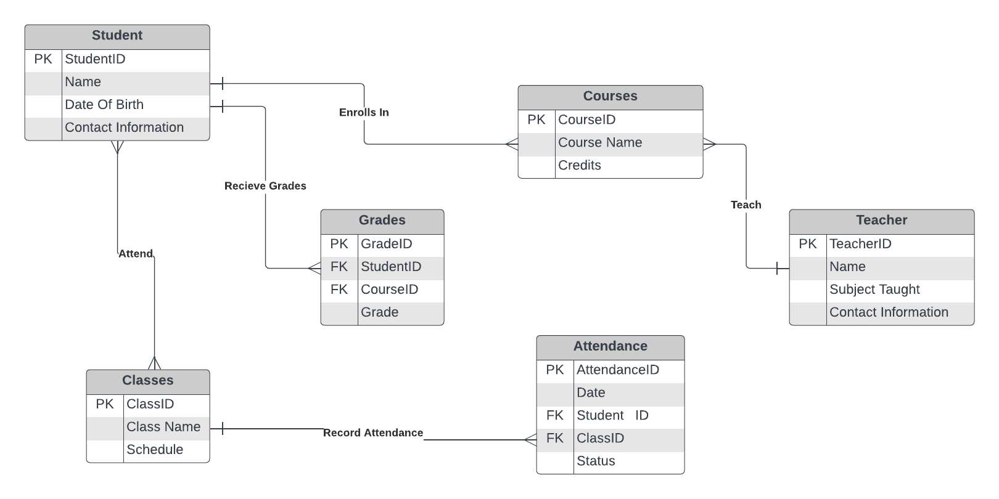

**7.RELATIONAL SCHEMA**

**STUDENT**

|  |  |  |  |
| --- | --- | --- | --- |
| STUDENT-ID | NAME | DATE OF BIRTH | CONTACT |

**CLASSES**

|  |  |  |
| --- | --- | --- |
| CLASS-ID | CLASS NAME | SCHEDULE |

**COURSES**

|  |  |  |  |
| --- | --- | --- | --- |
| COURSE-ID | COURSE NAME | CREADIT | CLASS-ID |

**GRADE**

|  |  |  |  |
| --- | --- | --- | --- |
| GRADE-ID | STUDENT-ID | COURSE-ID | GRADE |

**TEACHER**

|  |  |  |  |  |
| --- | --- | --- | --- | --- |
| TEACHER-ID | NMAE | SUBJECT | CONTACT | GRADE-ID |

**ATTENDENCE**

|  |  |  |  |  |  |
| --- | --- | --- | --- | --- | --- |
| ATTENDENCE-ID | DATE | STUDENT-ID | CLASS-ID | STATUS | TEACHER-ID |

**8.NORMALIZATION**

**i.STUDENT TABLE**

|  |  |  |  |
| --- | --- | --- | --- |
| **STUDENTID** | **NAME** | **DATE OF BIRTH** | **CONTACT** |
| **101** | **RAJIV YADAV** | **2004-08-09** | **9827736865** |
| **102** | **TEEJ KUMAR YADAV** | **2002-05-06** | **9856253654** |
| **103** | **RAJU CHAUDHARY** | **20000-01-02** | **9862323654** |
| **104** | **RASHIK SHAKIYA** | **2003-012-15** | **9825846855** |

**-THIS ABOVE TABLE IS ALREADY IN 1NF AND 2NF**

**3NF**

**STUDENT INFORMATION**

|  |  |  |
| --- | --- | --- |
| **STUDENT-ID** | **NAME** | **DATE OF BIRTH** |
| **101** | **RAJIV YADAV** | **2004-08-09** |
| **102** | **TEEJ KUMAR YADAV** | **2002-05-06** |
| **103** | **RAJU CHAUDHARY** | **20000-01-02** |
| **104** | **RASHIK SHAKIYA** | **2003-012-15** |

**STUDENT CONTACT**

|  |  |  |
| --- | --- | --- |
| **STUDENTID** | **NAME** | **CONTACT** |
| **101** | **RAJIV YADAV** | **9827736865** |
| **102** | **TEEJ KUMAR YADAV** | **9856253654** |
| **103** | **RAJU CHAUDHARY** | **9862323654** |
| **104** | **RASHIK SHAKIYA** | **9825846855** |

**ii.COURSES TABLE**

|  |  |  |
| --- | --- | --- |
| **COURSES-ID** | **COURSE NAME** | **CREDITS** |
| 123 | BIT | 126 |
| 234 | B.SC | 126 |
| 345 | ACCOUNT | 126 |
| 456 | HOTEL MANAGEMENT | 126 |

THIS ABOVE TABLE IS ALREADY IN 1NF AND 2NF.

3NF

COURSE INFORMATION

|  |  |
| --- | --- |
| **COURSES-ID** | **COURSE NAME** |
| 123 | BIT |
| 234 | B.SC |
| 345 | ACCOUNT |
| 456 | HOTEL MANAGEMENT |

COURSES CREADITS

|  |  |
| --- | --- |
| **COURSES-ID** | **CREDITS** |
| 123 | 126 |
| 234 | 126 |
| 345 | 126 |
| 456 | 126 |

iii.CLASSES TABLE

|  |  |  |
| --- | --- | --- |
| **CLASS-ID** | **CLASS NAME** | **SCHEDULE** |
| 1 | ENGLISH | 6:30AM |
| 2 | SCIENCE | 7:30AM |
| 3 | C.MATH | 8:30AM |
| 4 | PUBLIC SPEAKING | 9:30AM |

-THIS ABOVE TABLE IS ALREADY IN 1NF AND 2NF.

3NF

CLASS INFORMATION

|  |  |
| --- | --- |
| **CLASS-ID** | **CLASS NAME** |
| 1 | ENGLISH |
| 2 | SCIENCE |
| 3 | C.MATH |
| 4 | PUBLIC SPEAKING |

CLASS SCHEDULE

|  |  |
| --- | --- |
| **CLASS-ID** | **SCHEDULE** |
| 1 | 6:30AM |
| 2 | 7:30AM |
| 3 | 8:30AM |
| 4 | 9:30AM |

**iv.GRADE TABLE**

|  |  |  |  |
| --- | --- | --- | --- |
| **GRADE-ID** | **STUDENT-ID** | **COURSE-ID** | **GRADE** |
| 45 | 101 | 123 | P |
| 46 | 102 | 234 | P |
| 47 | 103 | 345 | P |
| 48 | 104 | 456 | F |

THIS ABOVE TABLE IS ALREADY IN 1NF AND 2NF.

3NF

|  |  |  |
| --- | --- | --- |
| **GRADE-ID** | **STUDENT-ID** | **COURSE-ID** |
| 45 | 101 | 123 |
| 46 | 102 | 234 |
| 47 | 103 | 345 |
| 48 | 104 | 456 |

|  |  |
| --- | --- |
| **GRADE-ID** | **GRADE** |
| 45 | P |
| 46 | P |
| 47 | P |
| 48 | F |

**V.TEACHER TABLE**

|  |  |  |  |
| --- | --- | --- | --- |
| **TEACHER-ID** | **NAME** | **SUBJECT** | **CONTACT** |
| 01 | MR.SANNU | BIT | 98566475265 |
| 02 | MISS.JANNU KUMAR | B.SC | 9858456321 |
| 03 | MR.YADAV KUMAR | ACCOUNT | 9863251425 |
| 04 | MR.SHIV KUMAR SAH | HOTEL MANAGEMENT | 9854623515 |

THIS ABOVE TABLE IS ALREADY IN 1NF AND 2NF.

3NF

|  |  |  |
| --- | --- | --- |
| **TEACHER-ID** | **NAME** | **SUBJECT** |
| 01 | MR.SANNU | BIT |
| 02 | MISS.JANNU KUMAR | B.SC |
| 03 | MR.YADAV KUMAR | ACCOUNT |
| 04 | MR.SHIV KUMAR SAH | HOTEL MANAGEMENT |

TEACHER CONTACT

|  |  |
| --- | --- |
| **TEACHER-ID** | **CONTACT** |
| 01 | 98566475265 |
| 02 | 9858456321 |
| 03 | 9863251425 |
| 04 | 9854623515 |

**Vi.ATTENDENCE TABLE**

|  |  |  |  |  |
| --- | --- | --- | --- | --- |
| **Attendence-id** | **Date** | **Student-id** | **Class-id** | **status** |
| 14 | 2023-09-01 | 101 | 1 | PRESENT |
| 15 | 2023-09-02 | 102 | 2 | PRESENT |
| 16 | 2023-09-03 | 103 | 3 | LATE |
| 17 | 2023-09-04 | 104 | 4 | ABSENT |

THIS ABOVE IS ALREADY IN 1NF AND 2NF.

3NF

|  |  |  |  |
| --- | --- | --- | --- |
| **Attendence-id** | **Date** | **Student-id** | **Class-id** |
| 14 | 2023-09-01 | 101 | 1 |
| 15 | 2023-09-02 | 102 | 2 |
| 16 | 2023-09-03 | 103 | 3 |
| 17 | 2023-09-04 | 104 | 4 |

|  |  |
| --- | --- |
| **Attendence-id** | **status** |
| 14 | PRESENT |
| 15 | PRESENT |
| 16 | LATE |
| 17 | ABSENT |

**Database Design**

The Database includes Table named Student, Teacher, Classes, Grades, Attendance and Courses. The SQL code used to create these tables are given below:

1. **Students**

CREATE TABLE Student (

StudentID INT AUTO_INCREMENT PRIMARY KEY,

Name VARCHAR(255) NOT NULL,

DateOfBirth DATE NOT NULL,

ContactInformation VARCHAR(255));

1. **Classes**

CREATE TABLE Classes (

ClassID INT AUTO_INCREMENT PRIMARY KEY,

ClassName VARCHAR(255) NOT NULL,

Schedule VARCHAR(255) NOT NULL

);

1. **Courses**

CREATE TABLE Courses (

CourseID INT AUTO_INCREMENT PRIMARY KEY,

CourseName VARCHAR(255) NOT NULL,

Credits INT NOT NULL

);

1. **Grades**

CREATE TABLE Grades (

GradeID INT AUTO_INCREMENT PRIMARY KEY,

StudentID INT NOT NULL,

CourseID INT NOT NULL,

Grade VARCHAR(2) NOT NULL,

CONSTRAINT fk_student FOREIGN KEY (StudentID) REFERENCES Student(StudentID),

CONSTRAINT fk_course FOREIGN KEY (CourseID) REFERENCES Courses(CourseID));

1. **Teachers**

CREATE TABLE Teachers (

TeacherID INT AUTO_INCREMENT PRIMARY KEY,

Name VARCHAR(255) NOT NULL,

SubjectTaught VARCHAR(255) NOT NULL,

ContactInformation VARCHAR(255));

1. **Attendance**

CREATE TABLE Attendance (

AttendanceID INT AUTO_INCREMENT PRIMARY KEY,

Date DATE NOT NULL,

StudentID INT NOT NULL,

ClassID INT NOT NULL,

Status ENUM('Present', 'Absent', 'Late') NOT NULL

);

**Screenshot of the interface**

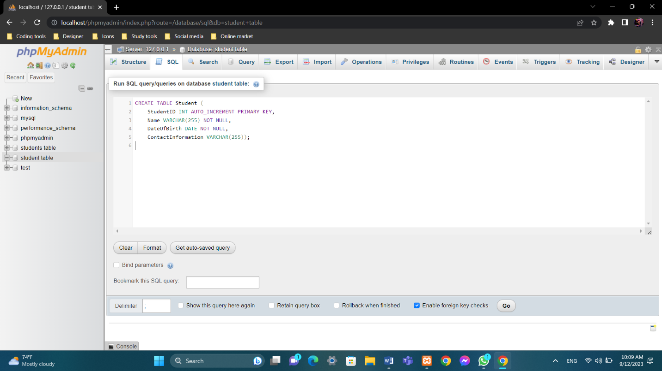

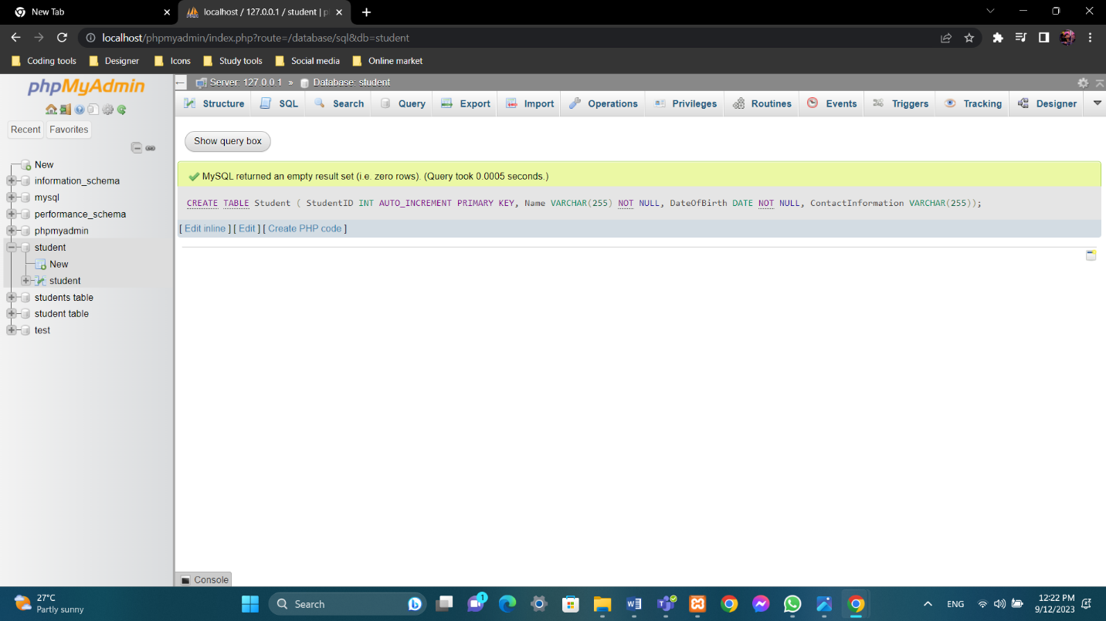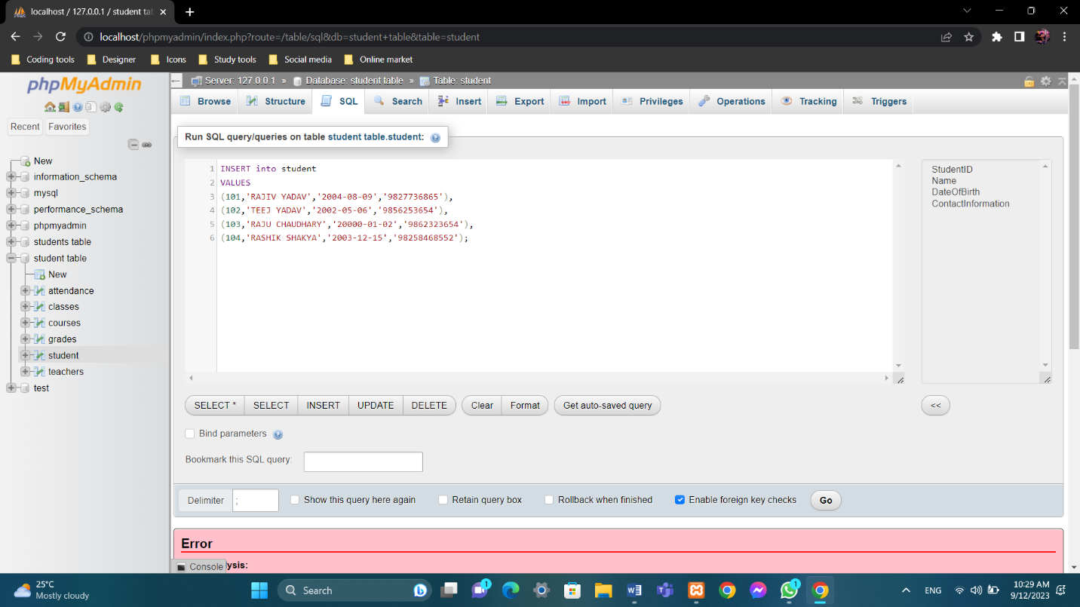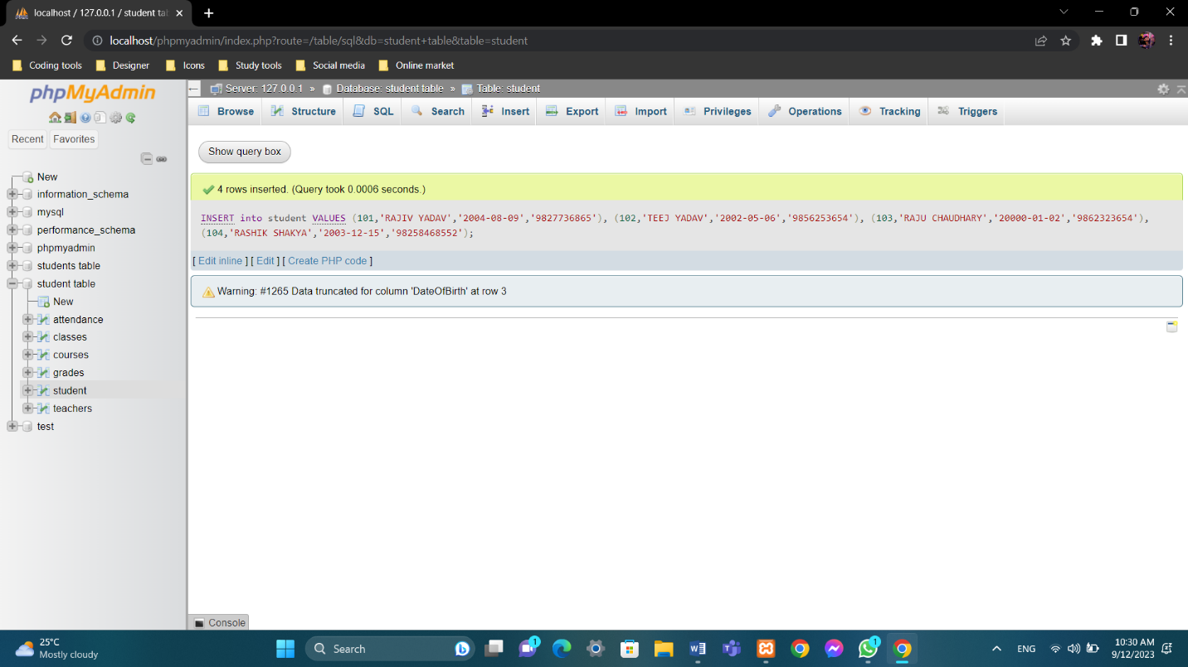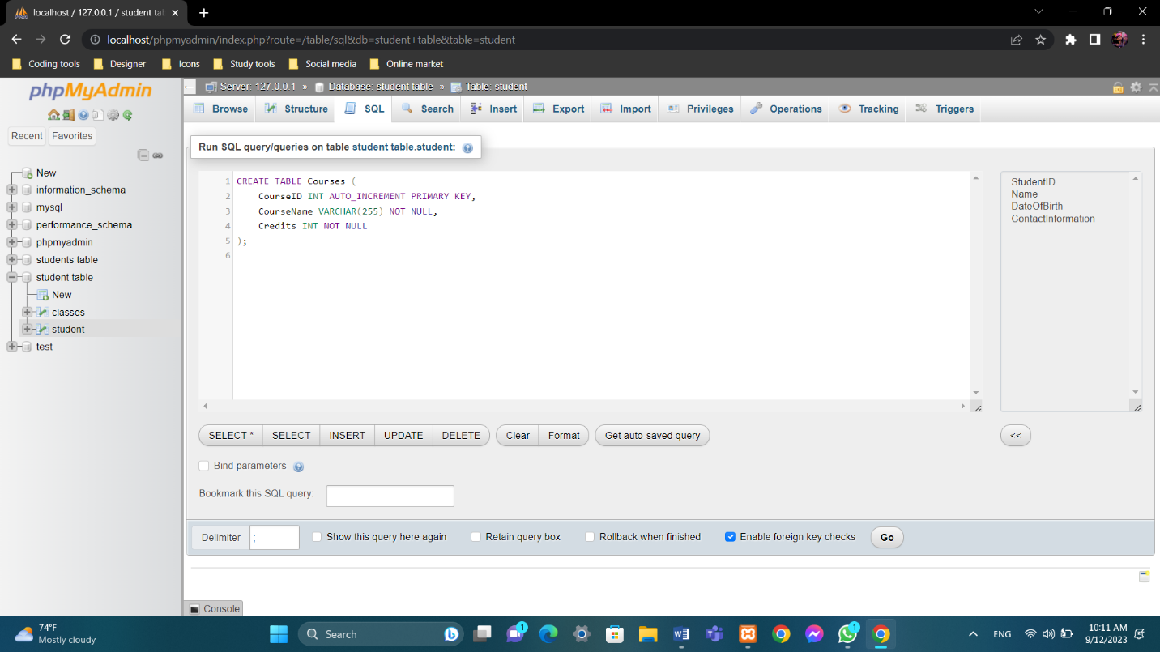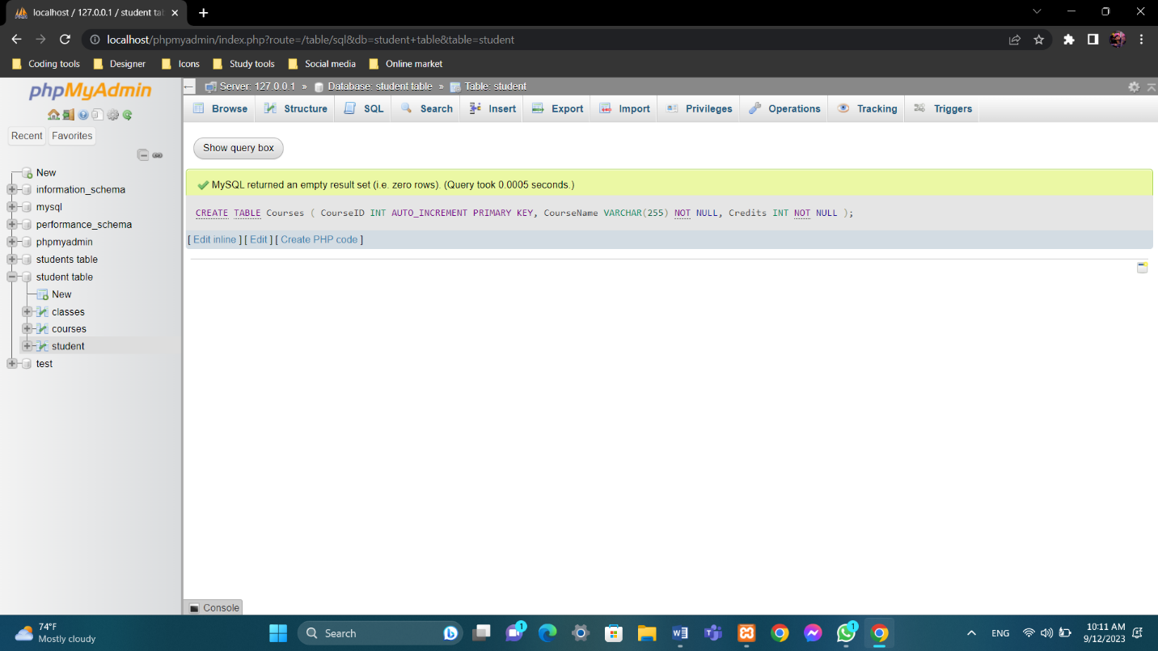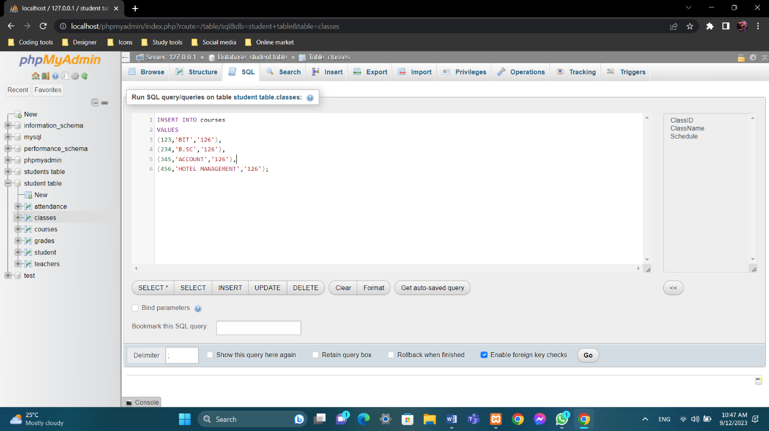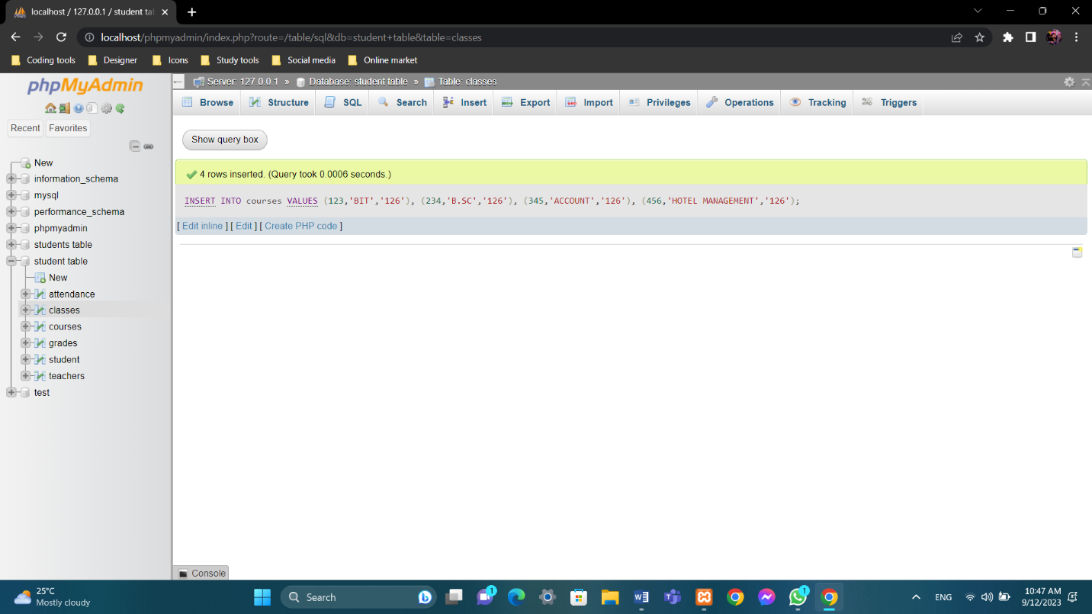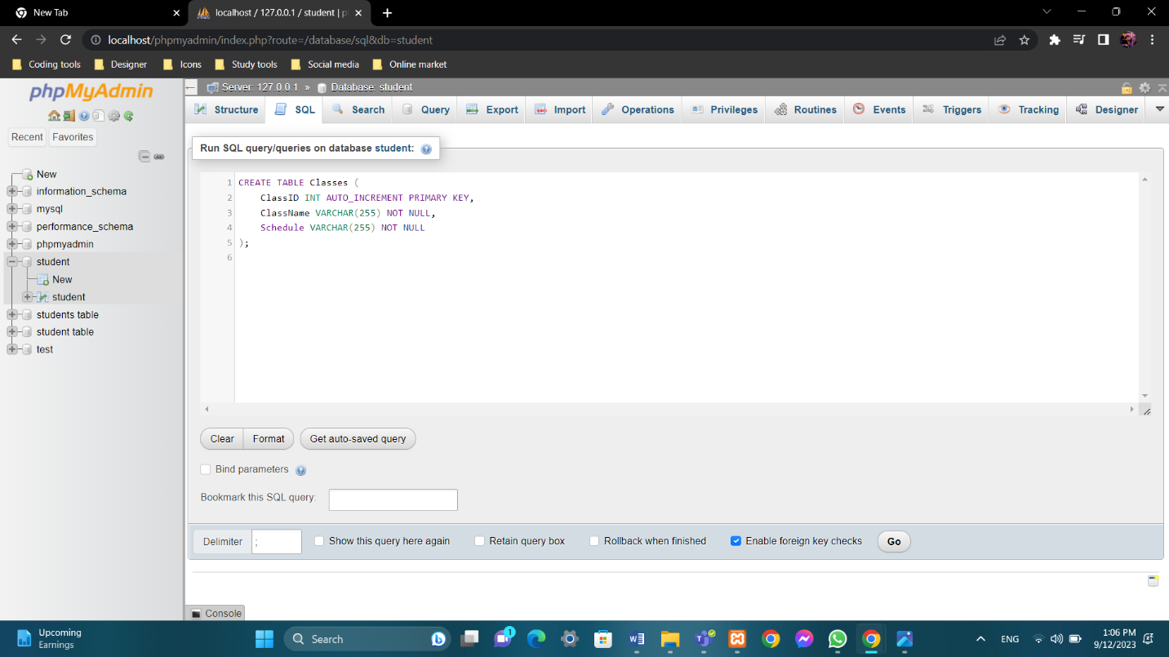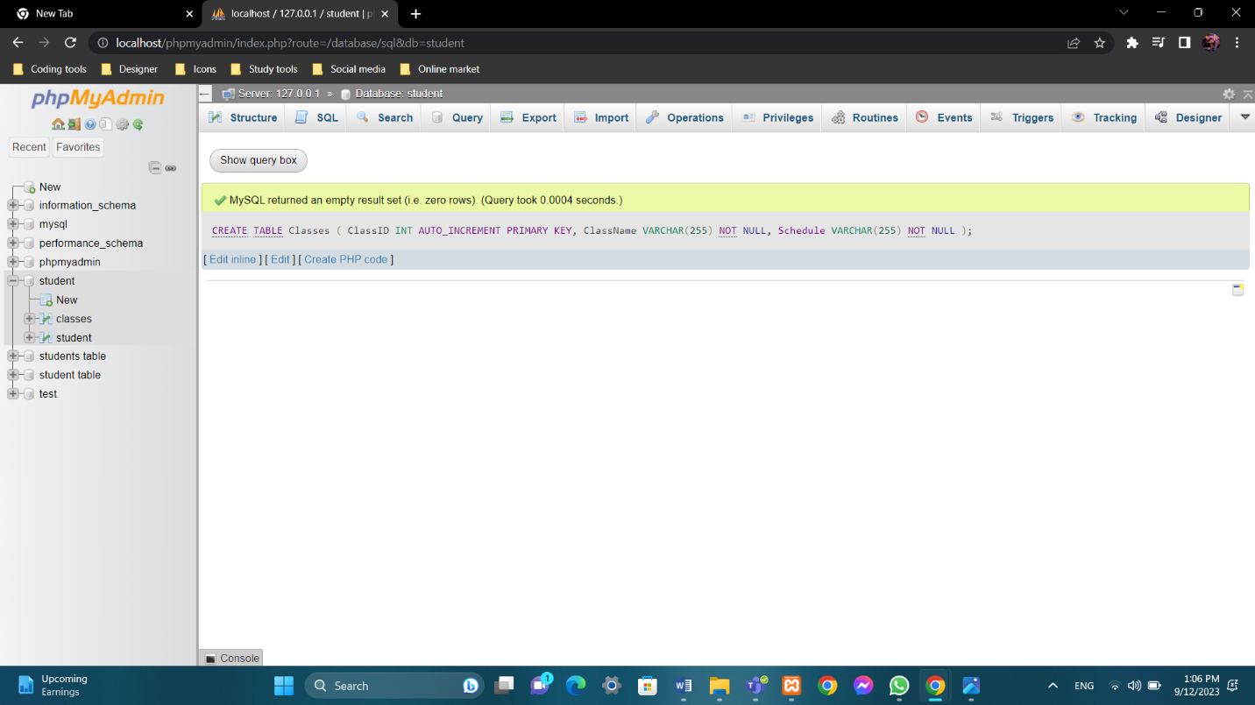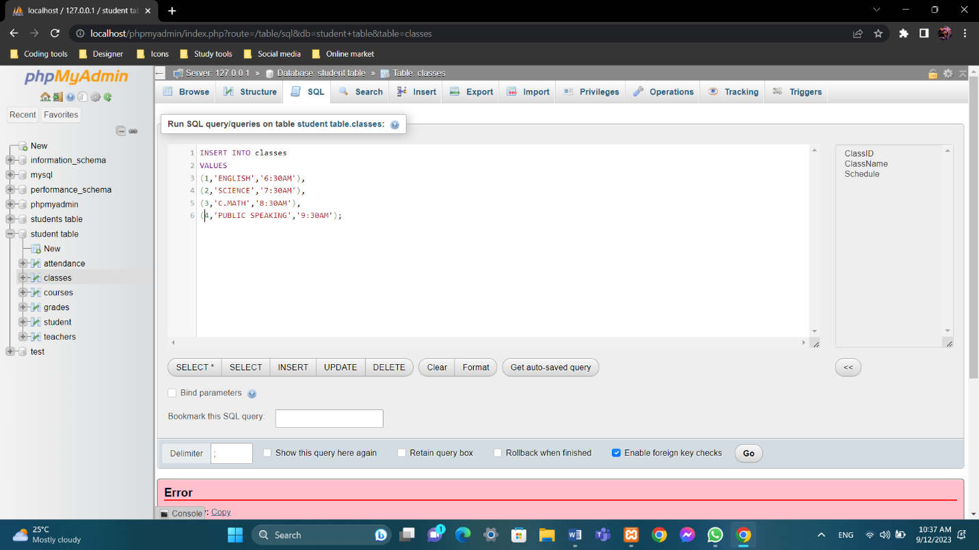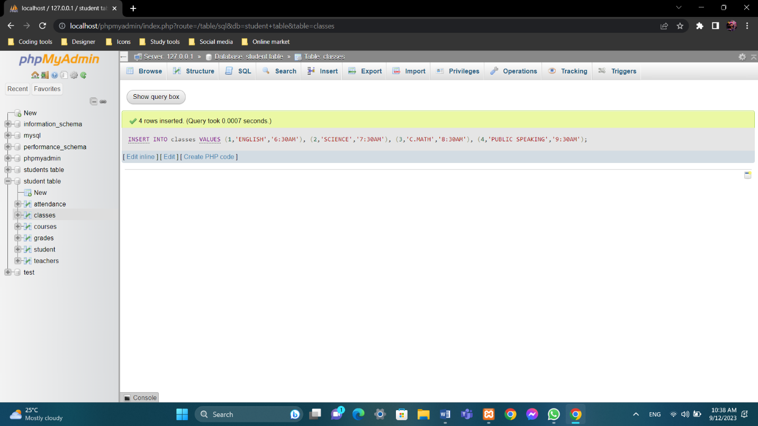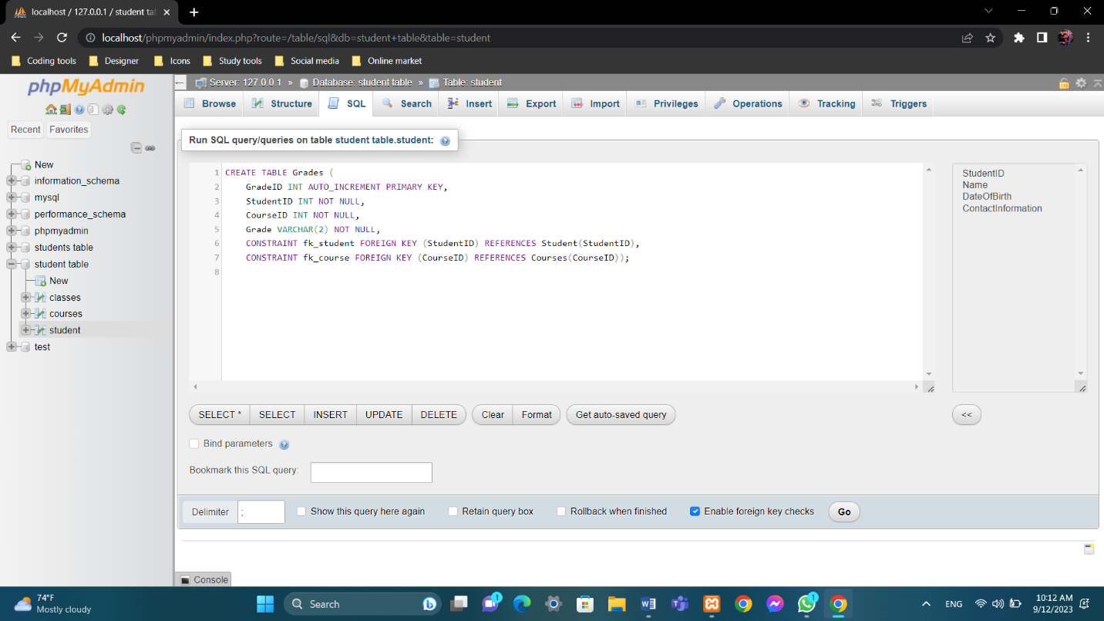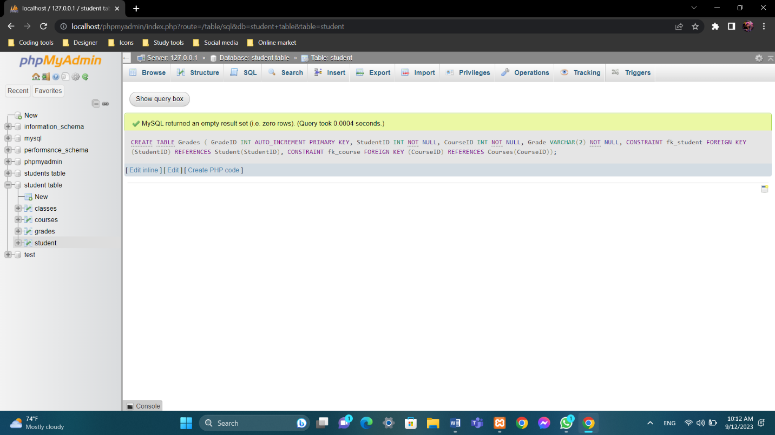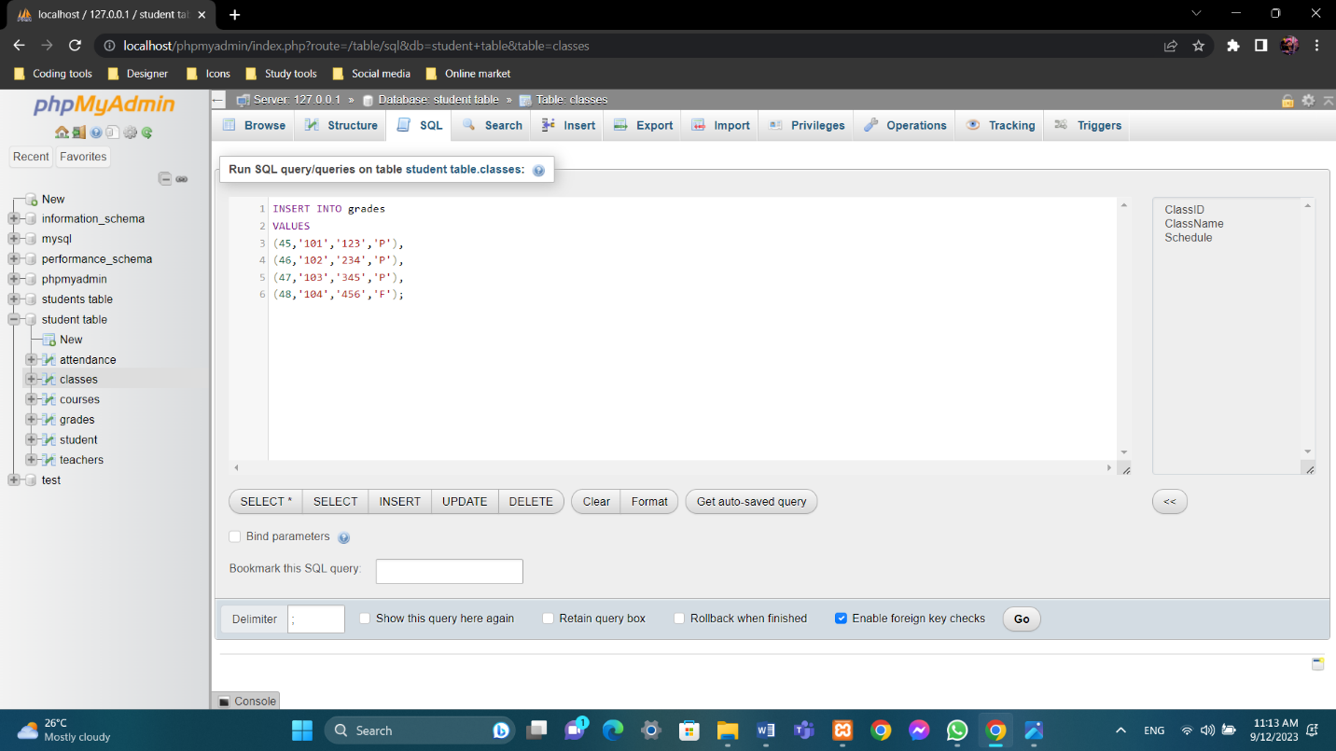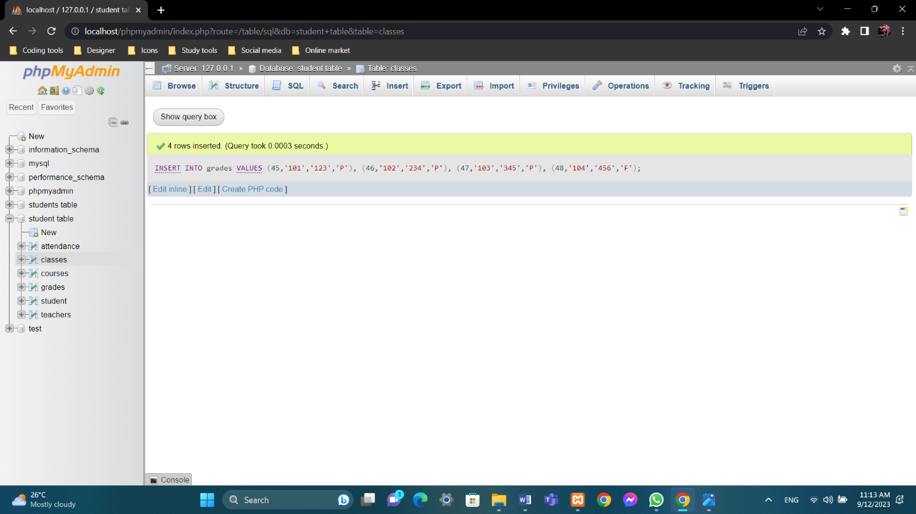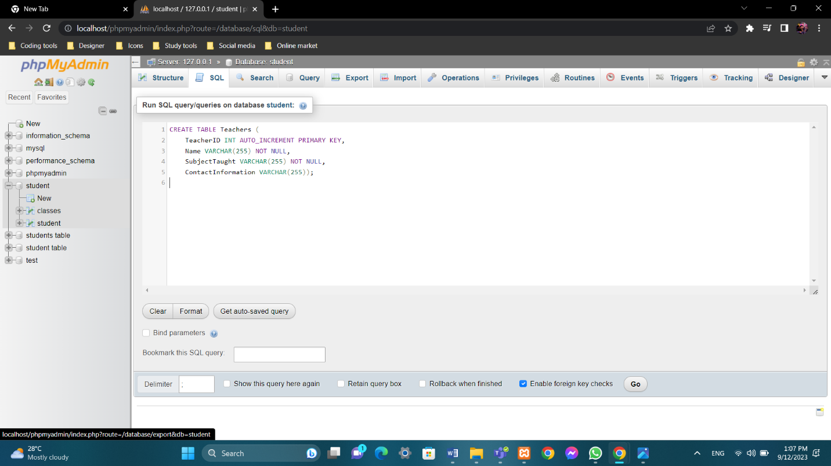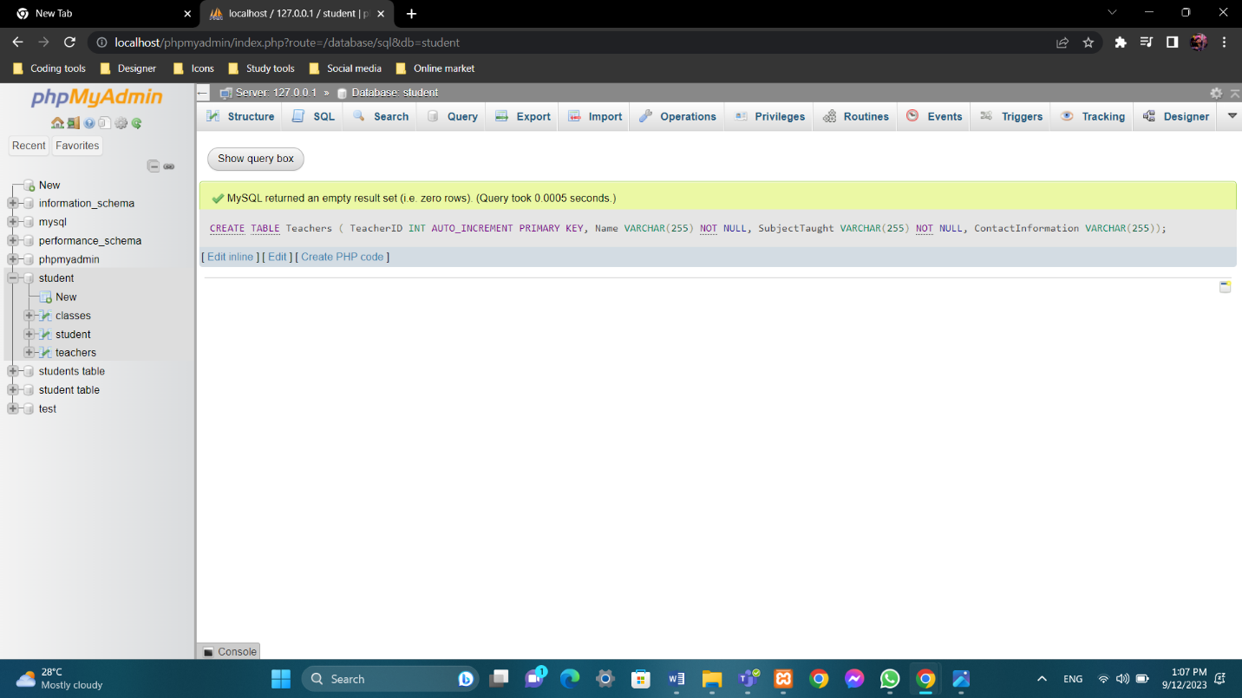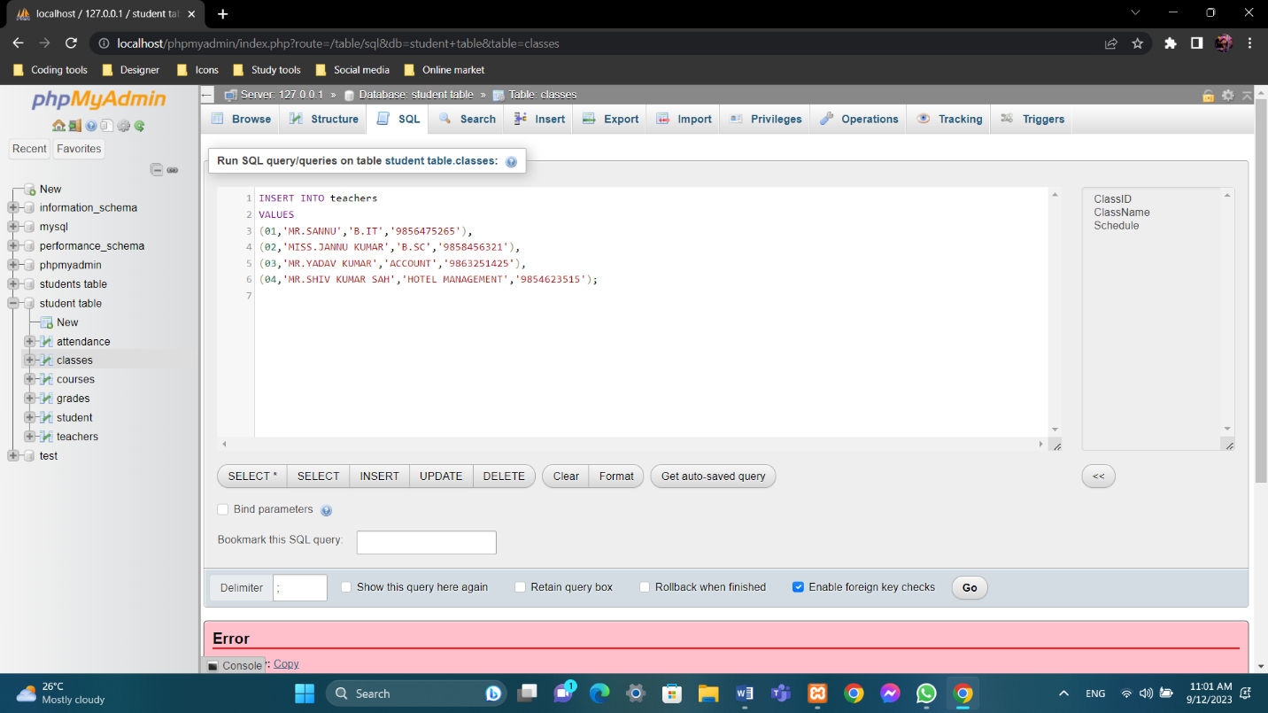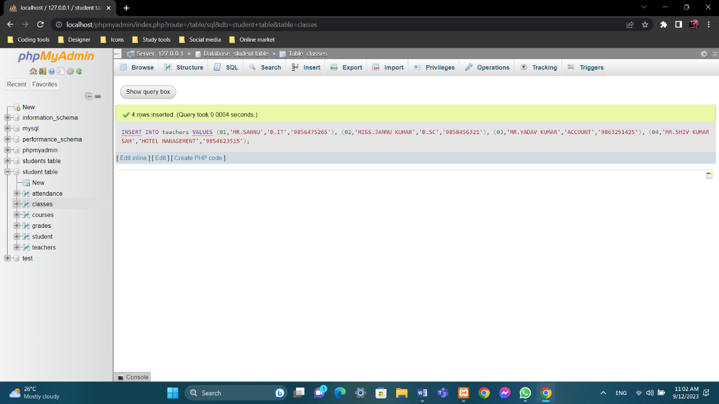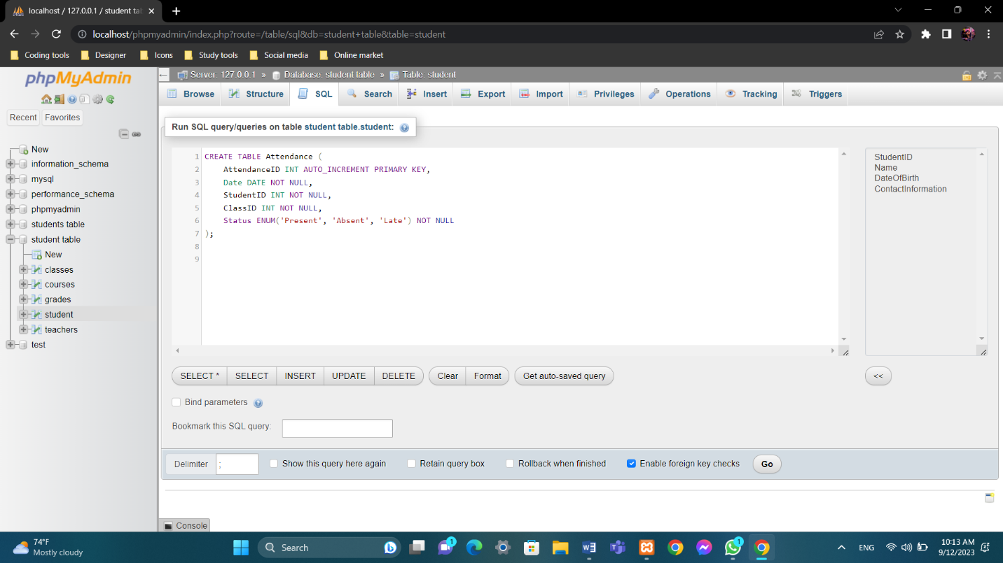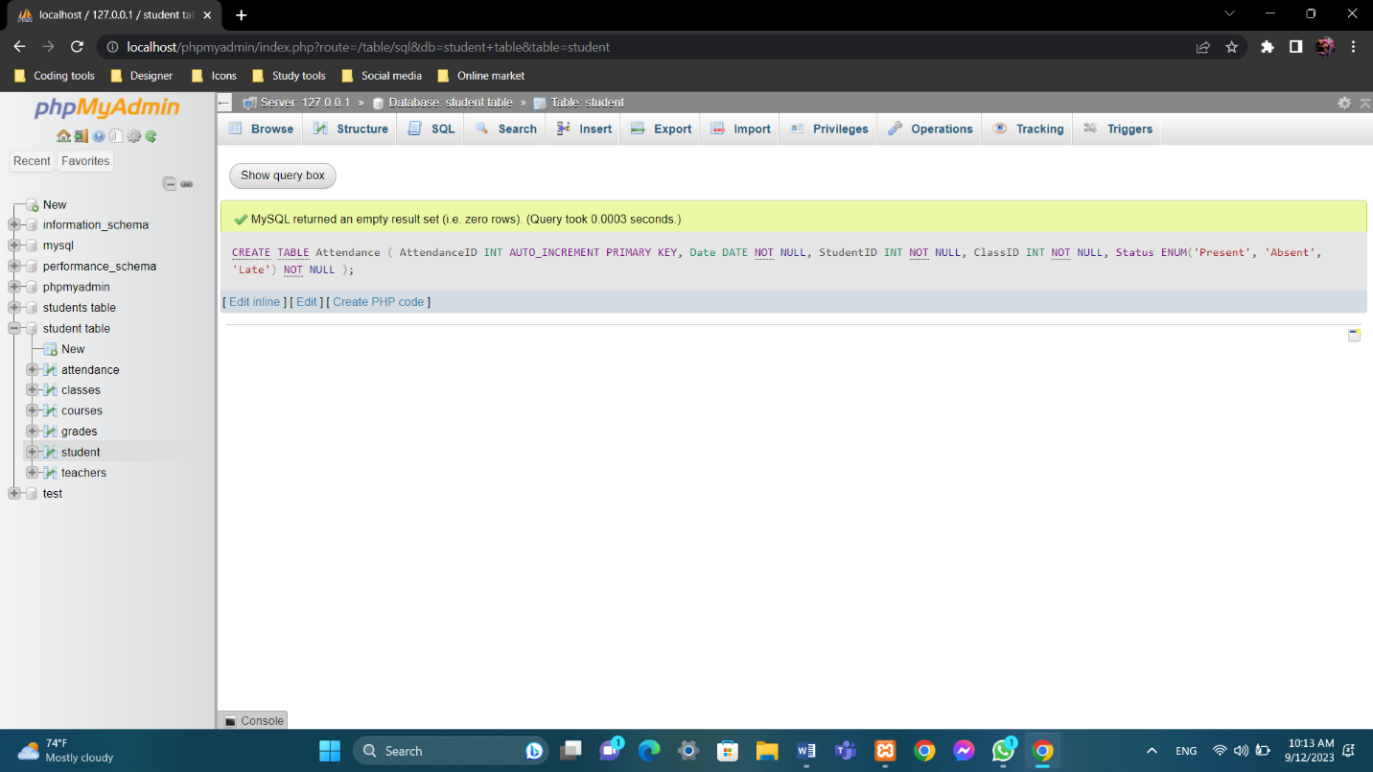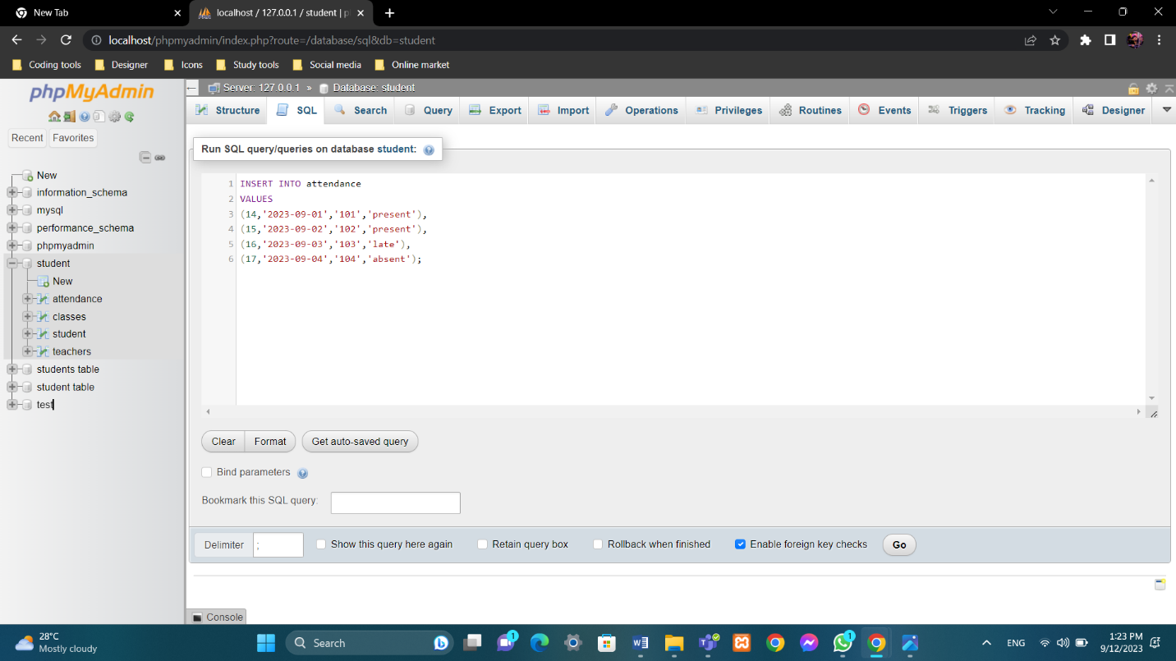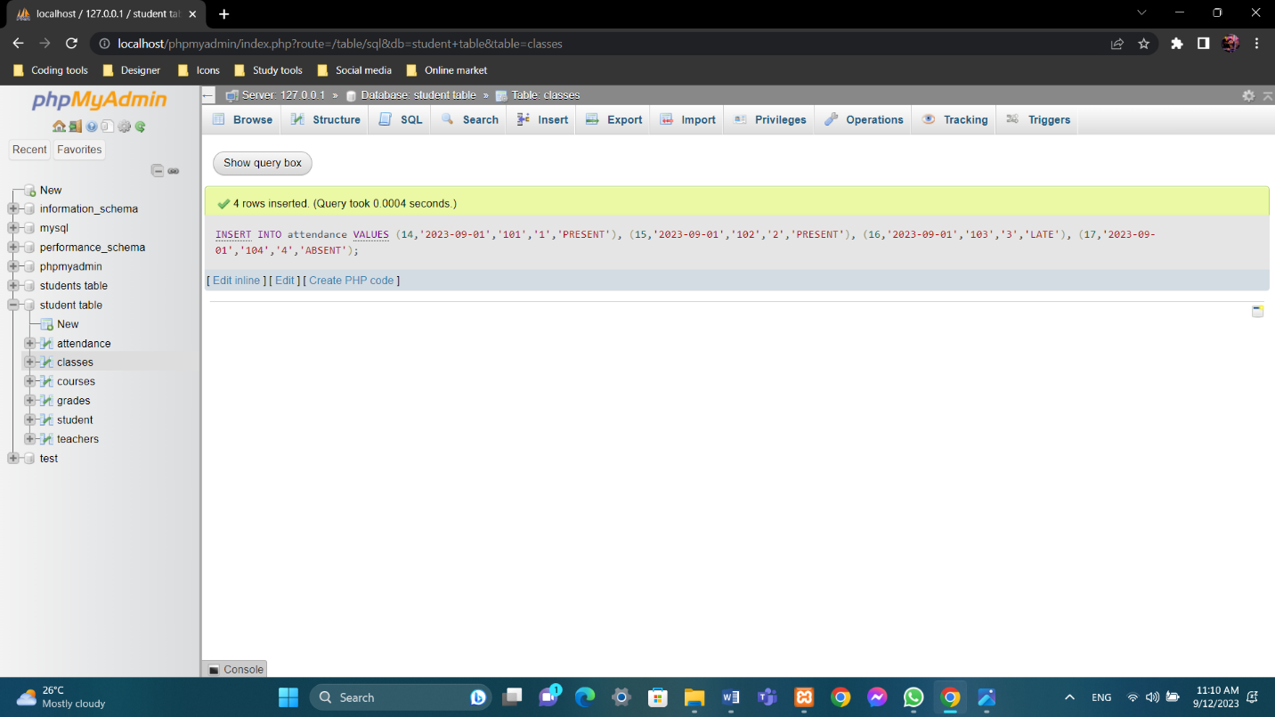

**Conclusion**

In this project, we have developed a comprehensive School Management System designed to revolutionize the way educational institutions manage their operations. This unique database system, built on the MySQL DBMS, offers a robust solution for enhancing administrative efficiency, ensuring data integrity, and improving communication and collaboration among stakeholders.

**Introduction to the System**

The School Management System addresses the complexities and challenges faced by educational institutions in managing their day-to-day activities. It encompasses various modules, including student management, teacher management, course management, attendance tracking, and grading, providing a holistic approach to managing educational processes.

**Advantages of the Developed System**

Our developed School Management System offers several significant advantages:

* **Efficiency:** Through automation of routine tasks, streamlined data entry, and real-time updates, administrative efficiency is greatly enhanced. This results in time and resource savings for educational institutions.
* **Data Integrity:** The centralized database ensures data consistency, reduces the risk of errors, and eliminates data redundancy. This leads to improved data accuracy and reliability.
* **Accessibility:** Stakeholders, including students, teachers, parents, and administrators, have secure, role-based access to relevant information. This fosters improved communication, collaboration, and transparency within the educational community.
* **Analytics and Reporting:** The system provides powerful tools for generating reports and analytics. Data-driven decision-making is facilitated, enabling institutions to make informed choices and enhance the quality of education.
* **Scalability:** The system is designed to accommodate future growth and evolving needs of educational institutions. As institutions expand, the system can adapt to meet their requirements seamlessly.

**Future Work and Suggestions**

While our School Management System represents a significant step forward in educational administration, there are opportunities for further enhancements and future work:

* **Mobile Accessibility:** Developing mobile applications to access the system can provide greater flexibility for stakeholders who are constantly on the move.
* **Integration with Learning Management Systems (LMS):** Integrating the School Management System with LMS platforms can create a unified ecosystem for managing both administrative and educational aspects.
* **Enhanced Security Measures:** Continuous improvements in security measures are essential to safeguard sensitive student and institutional data.
* **AI and Predictive Analytics:** Leveraging artificial intelligence and predictive analytics can help institutions make data-driven decisions and anticipate future trends.

In conclusion, our School Management System represents a significant advancement in educational administration. By embracing technology and automation, educational institutions can better focus on their core mission of providing quality education, while our system handles the administrative complexities efficiently and effectively. The future holds exciting opportunities for further development and innovation in the field of education management.

**EC3119 DATABASE SYSTEM**

**ASSIGNEMENT II MARKING SCHEME**

|  |  |  |
| --- | --- | --- |
| **PART A – DATABASE LOGICAL DESIGN** | | |
| **NO** | **TASK** | **MARKS** |
| **1.** | **Background**  Background should include the following:   * Introduction to current system * Problem with the existing system * How the problem could be solve using the proposed system | [ /5] |
| **2.** | **Objective**  The objective of current system **SHOULD NOT BE MORE THAN FIVE AND LESS THAN THREE** and it should be listed in bullet form. | [ /5] |
| **3.** | **Problem Statement**  -State what the problems with current process / system are | [ /5] |
| **4.** | **Scope**  -Define scope for your proposed system | [ /5] |
| **5.** | **Hardware & Software specification**  -Identify the hardware and software requirements to develop the system | [ /5] |
| **6.** | **Entity Relationship Diagram**  -Draw entity relationship diagram with its attributes | [ /15] |
| **7.** | **Database Schema**  -Provide the data schema for the proposed system. Data schema should be documented using the entity relationship diagram.  - Identify the primary and foreign key | [ /10] |
| **8.** | **Normalization**  - Normalize the table into 3NF | [ /10] |
|  | **PART A TOTAL** | [ /50] |

|  |  |  |
| --- | --- | --- |
| **Part B** | **System Development** | **Mark** |
| 1. | Achieve the scope mentioned in Part A | [ /3] |
| 2. | Able to run with free of errors | [ /3] |
| 3. | Has data validation | [ /3] |
| 4. | Enable Entity integrity and referential integrity | [ /3] |
| 5. | Overall design of the system / creativity | [ /3] |
|  |  |  |
| **PART B TOTAL** | | **[ /15]** |
| **Part C** | **Documentation** | **Mark** |
| 1. | All components listed in Part A | [ /5] |
| 2. | Print screen of result | [ /5] |
| 3. | Conclusions  **-**Must consist of brief introduction of your system  -Advantage of your developed system  -Limitations of your system  -Future work / Suggestion | [ /5] |
| **PART C TOTAL** | | **[ /15]** |
| **Part D** | **Description (Presentation)** | **Mark** |
| 1. | The presentation contained a brief and effective introduction | [ /2] |
| 2. | The explanation of the System design was clear and logical | [ /2] |
| 3. | Additional recommendations for expansion plan were helpful | [ /1] |
| 4. | The conclusions was satisfying and gave a sense of closure | [ /1] |
| 5. | Demonstration of the system | [ /2] |
| 6. | Able to answer question | [ /1] |
| 7. | Attire and cooperation of the group | [ /1] |
| **PART D TOTAL** | | [ /10] |
| **TOTAL A+B+C+D** | | [ /100] |